Slingo Money Train

Slingo Basics

How to Play

Select your stake and press SPIN to begin.

You have 10 spins to match numbers on the reel with numbers on the grid.

Complete Slingos to move up the pay ladder.

Slingo Line
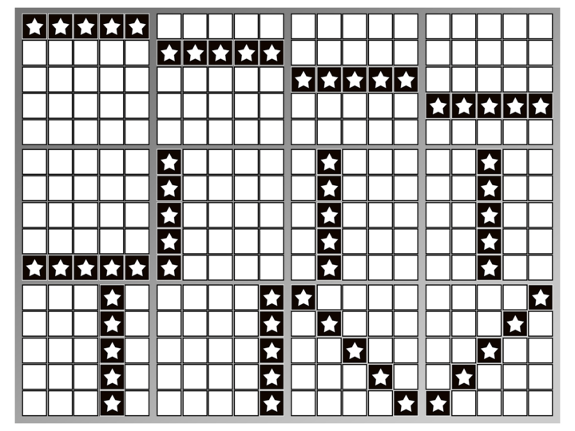

Multiple Slingo lines can be awarded by one dab.

There are 12 win lines and 11 awards because the last number on the grid will always award at least 2 winning lines.

WILD

Wilds allows you to mark any number in the column above.

SUPER WILD

Super Wilds allow you to mark any number in the grid.

Free Spin

Free Spin symbols add an extra spin.

Extra Spins

Extra Spins are available after each game.

The price of each spin is dependent on the grid position and potential prizes.

Prices may be in excess of your base stake.

Collect or buy extra spins.

The price of the next spin is shown on the spin button.

You Could Win

The potential wins available are displayed in turn.

The numbers required are highlighted.

Press collect to end the game.

Bonus Wheels

Gold Wheel

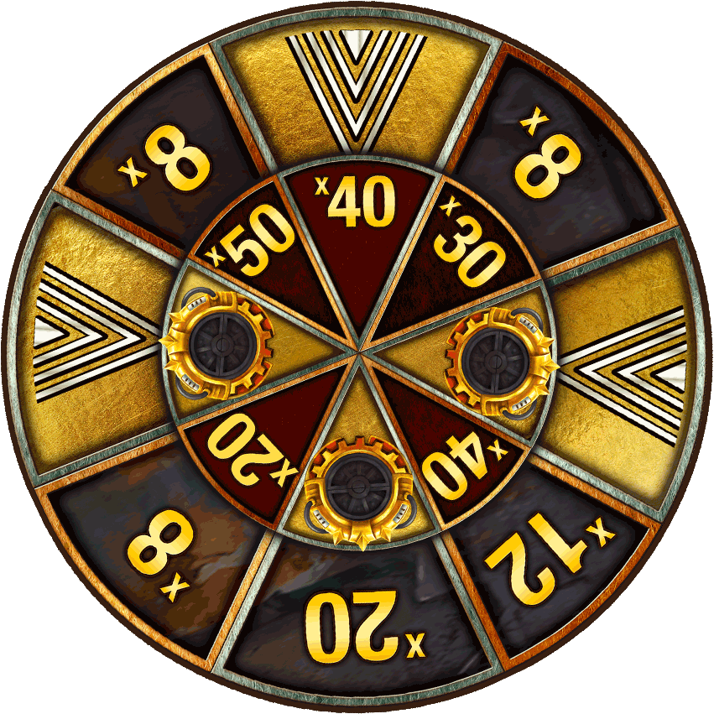
You can win a Gold Wheel by completing 8 Slingos.

The Gold Wheel offers cash or an entry to the Money Train Bonus at 1 x current stake. Min Multiplier x8 and Max Multiplier x50.

Silver Wheel
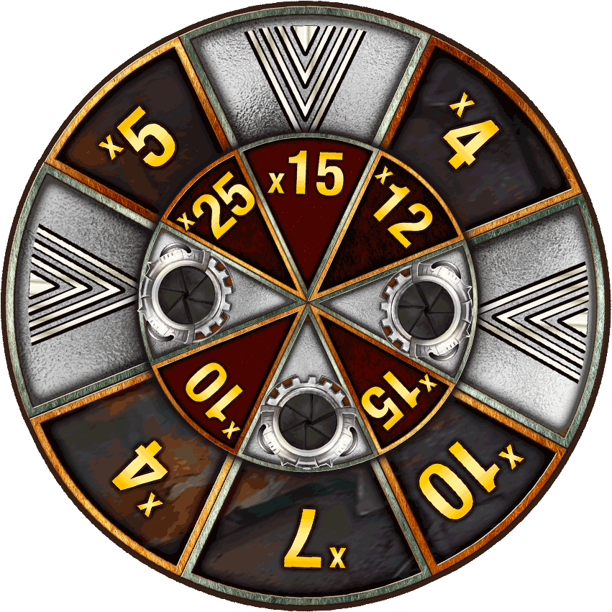
You can win a Silver Wheel by completing 7 Slingos.

The Silver Wheel offers cash or an entry to the Money Train Bonus at 0.5 x current stake. Min Multiplier x4 and Max Multiplier x25.

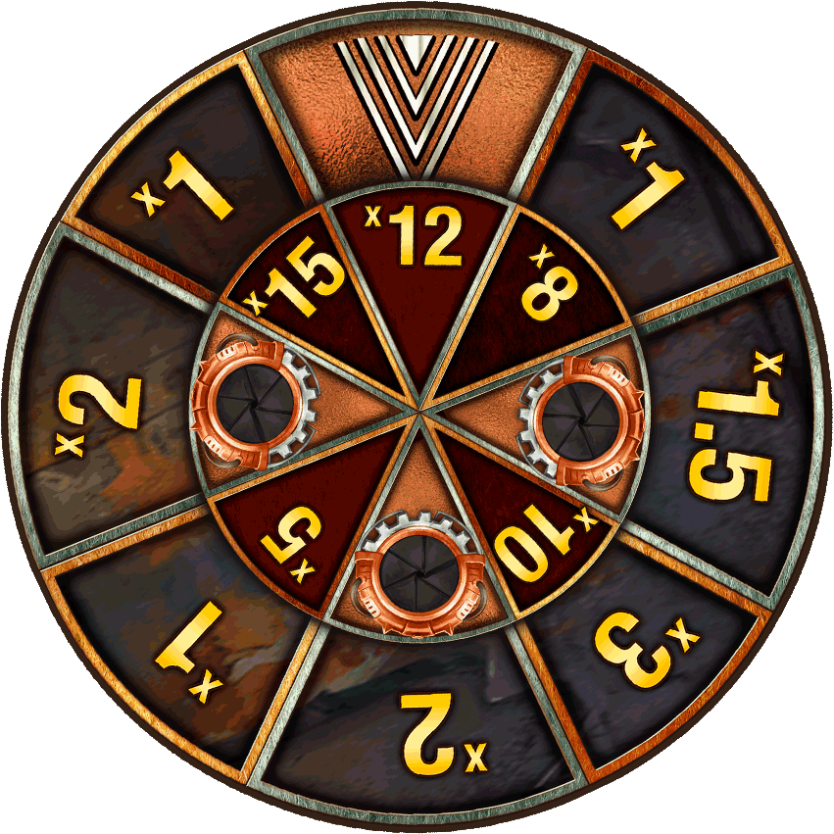
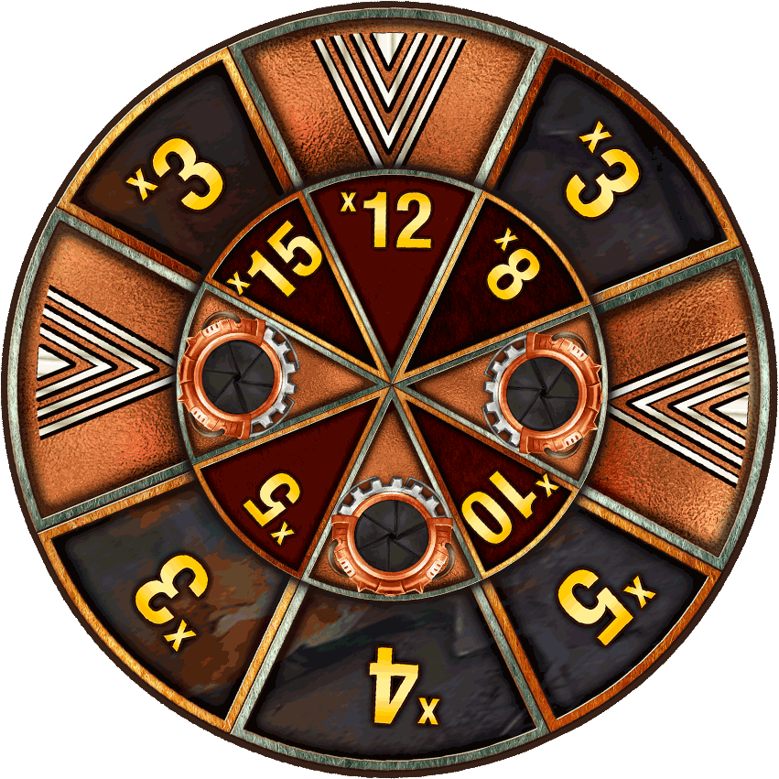
Bronze Wheels
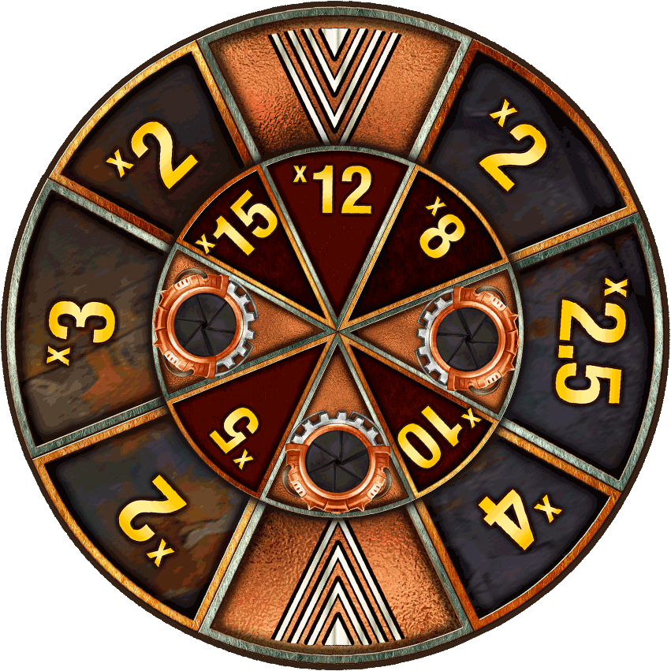

You can win a Bronze Wheel by completing 4, 5 or 6 Slingos

The Bronze Wheels offer cash or an entry to the Money Train Bonus at0.25 x current stake. Min Multiplier x1 and Max Multiplier x15.

Money Train Bonus Game

The Money Train Bonus is played on a 5x4 with Slot with 20 separate reels spinning.
If a column has 4 symbols displayed then the reel will expand and this can expand to a maximum size of 7x4.

All wins are delivered as multipliers of the Bonus Stake on the completion of each spin.

Bonus Symbols

Payer
Reveals a value as a multiplier of the bonus bet and adds its own value to all other visible symbols on the reels. Min Multiplier x1 and Max Multiplier x10.

Collector

Reveals a value as a multiplier of the bonus bet and then collets all visible values on the reels and adds them to its own value. Min Multiplier x1 and Max Multiplier x10.

Collector-Payer
Reveals a value as a multiplier of the bonus bet and adds the sum of all other visible values to its own value, then adds the updated value to all other visible symbols on the reels. Min Multiplier x1 and Max Multiplier x200

Sniper

Reveals a value as a multiplication of bet and doubles the values of 3 to 8 other bonus symbols. It can act on the same bonus symbol several times. Min Multiplier x1 and Max Multiplier x10.

Necromancer
Reveals a value as a multiplier of the bonus bet and brings between 2 and 7 already used non-persistent special bonus symbols to life again. (Collector, Payer, Collector/Payer or Sniper). Min Multiplier x1 and Max Multiplier x10.

Reset Plus
Reveals a value as a multiplier of the bonus bet and increases by one the starting value of the remaining spins. Min Multiplier x1 and Max Multiplier x10.

Bonus Symbol

Reveals a value as a multiplier of the bonus bet. Min Multiplier x1 and Max Multiplier x200

Persistent Symbols

Persistent Payer

Reveals a value as a multiplier of the bonus bet and adds it to all other visible symbols on the reels for that spin and any subsequent spin. This symbol does not pay itself. Min Multiplier x1 and Max Multiplier x10

Persistent Sniper
Reveals a value as a multiplier of the bonus bet and doubles the value of 3 to 8 other bonus symbols at the end of that spin and any subsequent spin. It can act on the same bonus symbol several times. Min Multiplier x1 and Max Multiplier x10

Persistent Collector
Reveals a value as a multiplier of the bonus bet and collects all visible values on the reels and adds them to its own value at the end of that spin and any subsequent spin. This symbol does not collect its own value. Min Multiplier x1 and Max Multiplier x10.

Money Train Bonus Game Rules
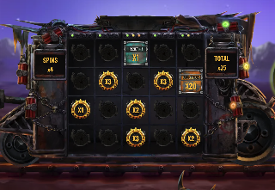

The bonus game can be triggered directly from the Slingo Ladder or via a Bonus Wheel.

Gold Bonus bet is equal to 100% of initial game bet.

Silver Bonus bet is equal to 50% of initial game bet.

Bronze Bonus bet is equal to 25% of initial game bet.

All values in the feature will be displayed as a multiplication of the Bonus bet.

When the Bonus is triggered, 3 Bonus Symbols will appear on the reels before the Bonus begins.

Each symbol will reveal a value and play their action before the first spin.

The bonus round always starts with 3 spins and each time a new symbol is landed the spin count resets.

When you fill a reel with symbols, an additional reel will be opened. This can happen a maximum of twice per bonus round.

If both additional reels have been revealed and a symbol is placed in every possible position, the bonus round will end whilst awarding 500x the bonus bet used when triggering the feature.

Slingo Information

Best Strategy

The best strategy dictates that the selection for positions of Wilds and Super Wilds is always in the position that will move the player closer to completing a Slingo.

Where multiple positions with the same criteria are available, the preference is given to positions which are included in the most Slingos (win lines). Where this is not applicable, a random choice is made.

For example the central square would be given preference since it is included in a horizontal, vertical and two diagonal lines.

Rules

All symbols occur on all reels.

Free spins symbols award an additional spin.

Extra spins are available after each game.

Based on best strategy the standard game has a theoretical RTP of 94.42%.

Based on best strategy each extra spin has a theoretical RTP of 94.47%.

Minimum multiplier win in the Bonus Game wheels is x1.

Maximum multiplier win in the Bonus Game wheels is x50.

The maximum win from the Money Train Bonus Game is x10000.

Prices are rounded to the nearest whole value which may alter the RTP.

Malfunction voids pays and plays.

In extra spins some potential prizes may require Super Wilds.

Pending Games

Incomplete games will be automatically completed 24 hours after launch.

Any remaining spins will be played out with a random number generator used to make any player decisions.

Any winnings will be automatically credited.

