Slingo Basics
Slingo Lucky Joker is the fast-paced game where slots meets bingo with big cash prizes available.

Select your stake and press spin to start the game.

You have 8 spins to match numbers on the reel with the grid.

Complete Slingos to move up the pay ladder.

The cash prize increases with every Slingo (win line) you complete.

There are 12 win lines and 11 awards on the paytable because the last number on the grid will always award at least 2 winning lines.

Symbols
Wilds allow you to mark any number in the column above.

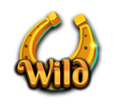

Super Wilds allow you to mark any number in the grid.

Free Spin symbols add additional spins.

3 Bonus Wheel symbols trigger 5 Bonus Wheel spins.

3 Bonus Slot symbols award 15 extra spins on the Bonus Slot.

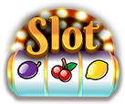

Extra Spins
Extra spins are available after each game.

The price of each spin is dependent on the grid position and potential prizes.

Prices may be in excess of your base stake.

Press collect to end the game or buy more spins.

The price of the next spin is shown on the spin button.

Trail Game
The game includes a trail that surrounds the Slingo grid.

There are fixed-prize positions on the grid - one prize in the centre of each side and one in the bottom right-hand corner.

At the start of every game, the possible prizes are randomly assigned to the available prize locations.

A dice and Joker appear in the top left-hand corner at the start of the game.

With each spin, the Joker moves clockwise around the board, immediately awarding any prize he lands upon. The Joker will move 1-6 spaces per spin as determined by the dice roll.

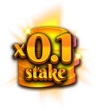 | 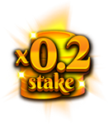 | 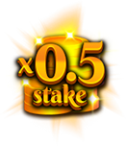 | 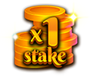

Bonus Wheel
The Bonus Wheel is triggered when 3 Bonus Wheel symbols land in a single spin or by reaching 6 or more Slingos on the prize ladder.

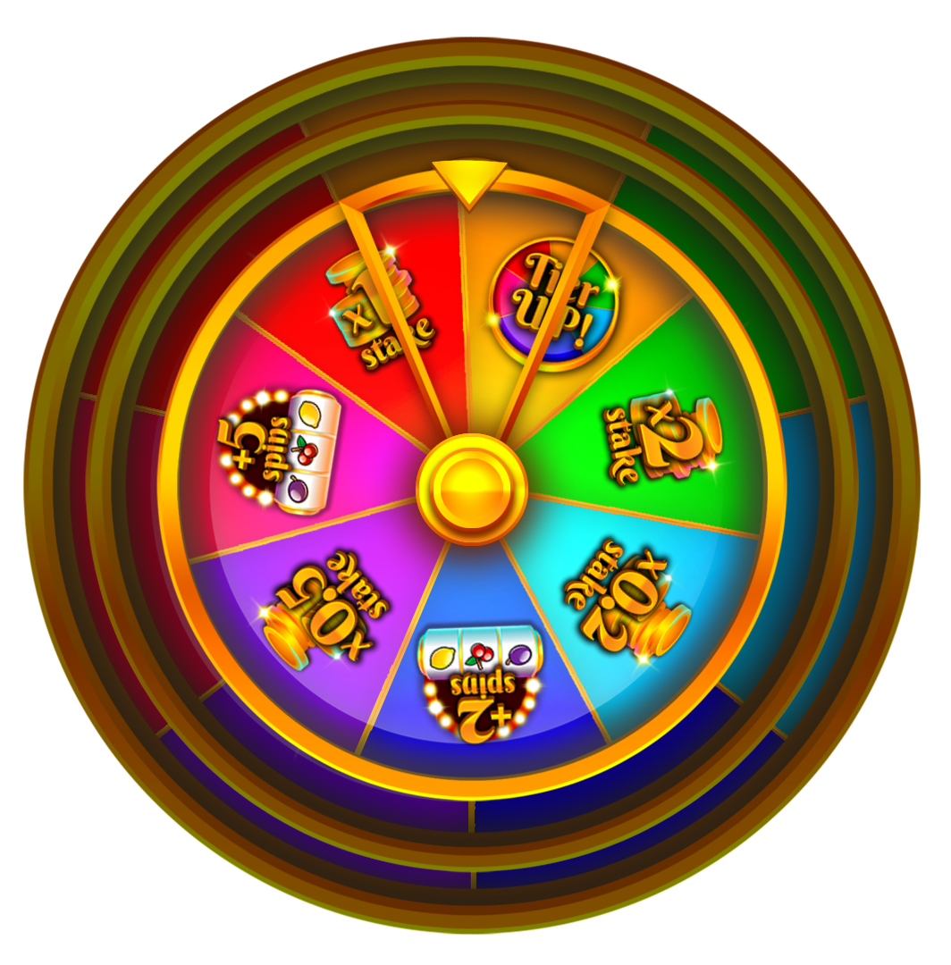

Cash Prizes

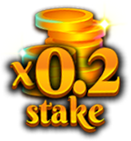 | 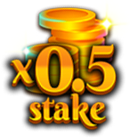 | 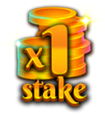 | 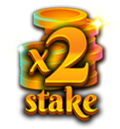 | 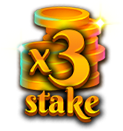
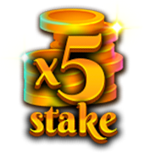 | 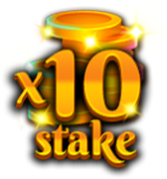 | 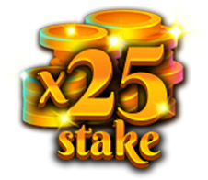 | 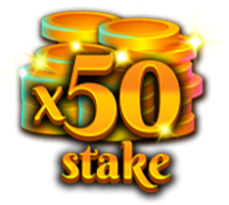 | 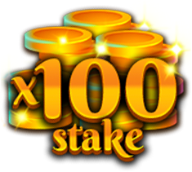
 |  | 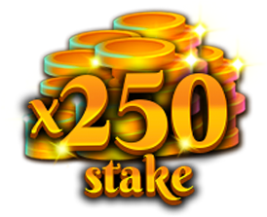

Extra Bonus Slot spins

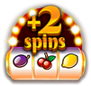  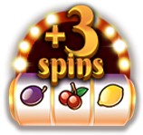 | 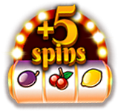 | 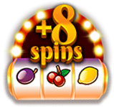 | 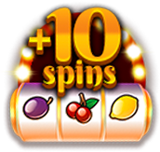 | 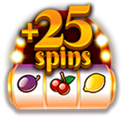

Upgrade Bonus Wheel tier for a chance to win bigger prizes.

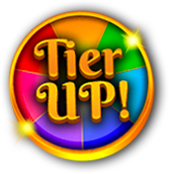

Minimum win on any Bonus Wheel is x0.2 base stake or 2 slot spins.

Maximum win on any Bonus Wheel is x250 base stake.

Bonus Slot
At the end of a game the Bonus Slot plays all awarded spins. Bonus Slot spins are awarded when 3 Bonus Slot symbols land in a single spin or are awarded on the Slingo prize ladder and/or the Bonus Wheel.

The Wild Joker symbol may only appear on the 3 central reels.

When a Wild Joker symbol lands, it expands to fill the entire reel before wins are calculated.

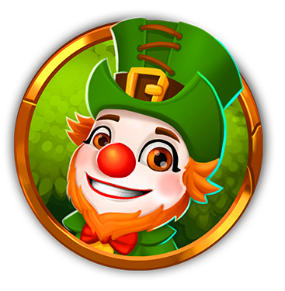

Minimum win on the Bonus slot is x5 the line stake.
Maximum win on the Bonus slot is x100 base stake.

Symbol Payouts
Line pay combinations are multiplied by the bet per line.

Scatter wins are multiplied by the total bet.

Scatter wins are paid in addition to other wins.

If one or more Wild Joker symbols participates in a win, then that win is doubled.

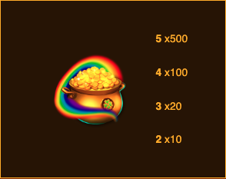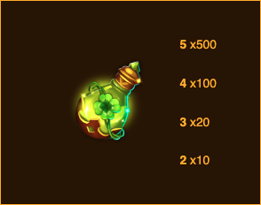

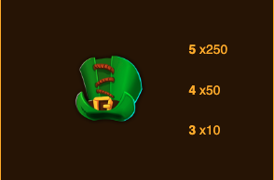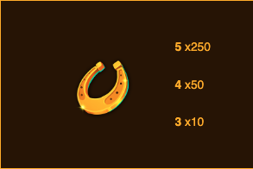

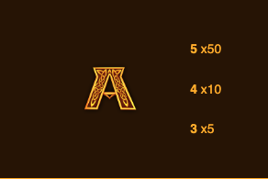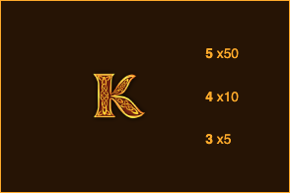

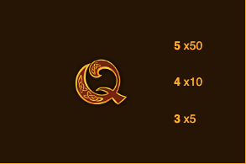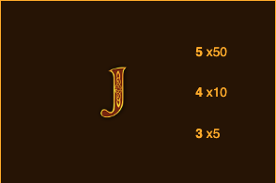

Slot Win Lines
Only the highest winning combination is paid per line.

Bet line wins pay from left to right except scatter wins, which may occur in any position.

Malfunction voids pays and plays.

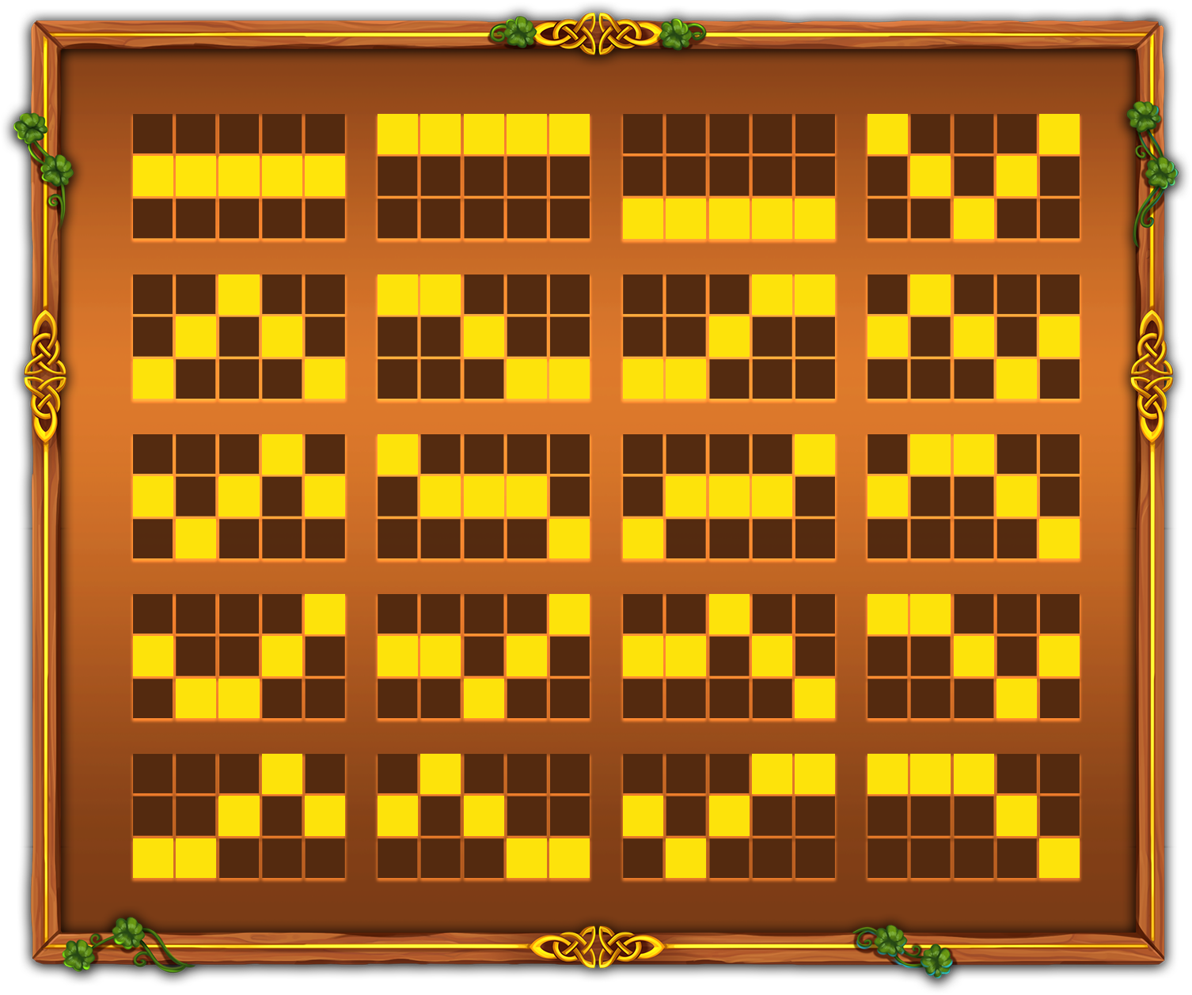

Slingo Win Lines
There are 12 win lines and 11 awards because the last number on the grid will always award at least 2 winning lines.

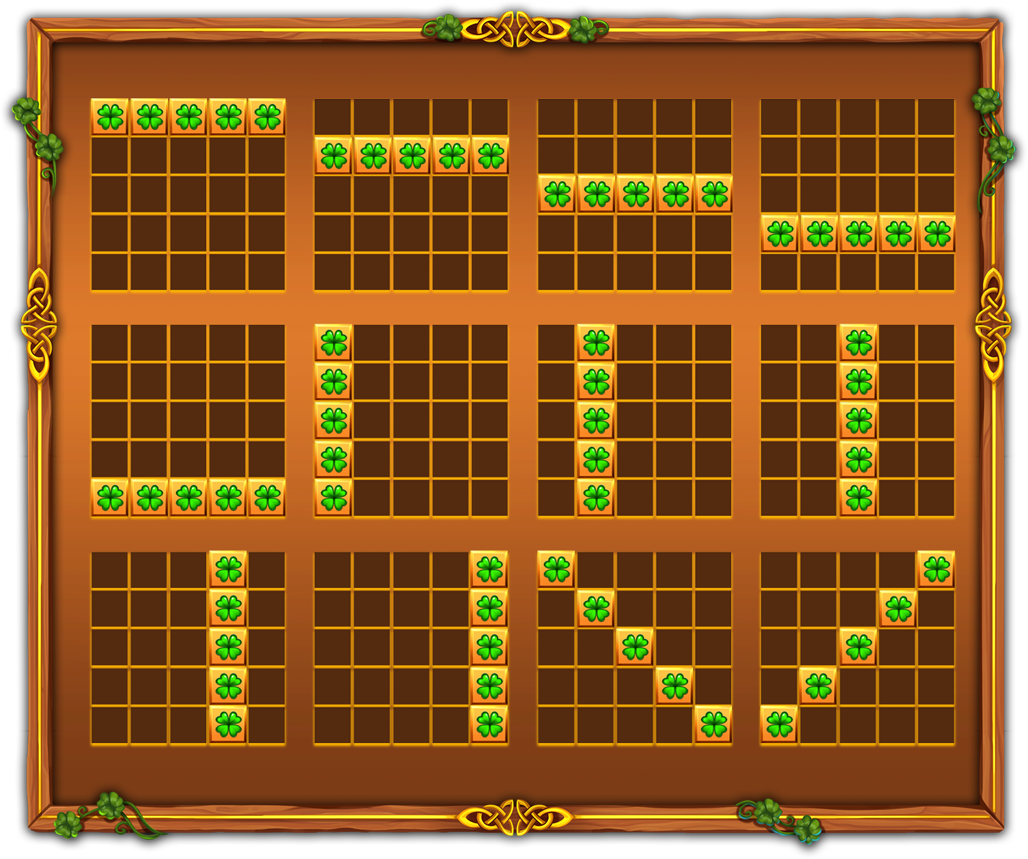

Best Strategy
The best strategy dictates that the selection for positions of wilds and super wilds is always in the position that will move the player closer to a Slingo.

Where multiple positions with the same criteria are available the preference is given to the positions that are included in the most Slingos (win lines).

For example, the centre square would be given preference since it is included in a horizontal, vertical and two diagonal lines. Where multiple positions with the same criteria exist again a random choice is made.

General Rules
Based on the best strategy this game has a theoretical RTP of 94.27%.

Based on the best strategy each extra spin has a theoretical RTP of 94.00%.

Free spins symbols are removed from the reels for extra spins.

In extra spins some potential prizes may require Super Wilds.

Extra spins are only offered if a bonus is achievable on the next spin.

Extra spin prices are rounded to the nearest whole value which may affect the RTP, especially at lower stakes.

Malfunction voids all pay and play.

Pending Games
Incomplete games will be automatically completed 24 hours after launch.

Any remaining spins will be played out with a random number generator used to make any player decisions.

Any winnings will be automatically credited.

